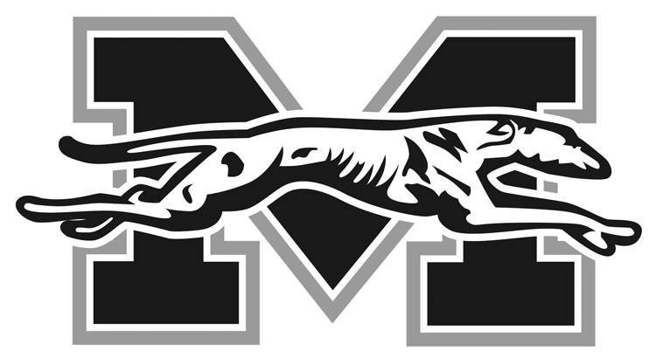
MORAVIAN COLLEGE SPORTS NEWS
Sports Information Office

Mark Fleming, Director
1200 Main Street
Bethlehem, PA 18018

Telephone: (610) 861-1472
FAX: (610) 625-7954
Email: sportsinfo@moravian.edu

Revised, November 4, 2016

2016-17 MORAVIAN COLLEGE

MEN’S BASKETBALL ROSTER

NO NAME YR POS HT WT HOMETOWN/HIGH SCHOOL
0 John Hargraves Fr. F 6-4 216 Philadelphia, Pa./Monsignor Bonner & Archbishop Prendergas
1 Khalil Rhett Jr. G 6-2 180 Merchantville , N.J./Pennsauken
2 Sean Hanna Sr. G 6-0 170 Philadelphia, Pa./Father Judge
3 Will Brazukas So. G 5-11 160 Philadelphia, Pa./Father Judge
4 Tom Cicalese Sr. G 5-11 165 Fords, N.J./St. Josephs
5 Oneil Holder So. F 6-5 185 East Stroudsburg, Pa./East Stroudsburg South
10 Mike Martino Fr. G 5-10 165 Roseto, Pa./Bangor
11 Jimmy Murray So. G 6-0 160 Plymouth Meeting, Pa./Plymouth Whitemarsh
12 Elijah Davis Fr. G 6-0 170 Ewing, N.J./South Hunterdon
13 Tyron Brown Fr. G 5-10 165 Harrisburg, Pa./Milton Hershey School
15 Nicholas Casazza So. G 5-11 160 Honesdale, Pa./Honesdale
20 C.J. Barnes Fr. G 6-3 175 Egg Harbor Township, N.J./Holy Spirit
21 Jake McGee So. G 6-1 190 Broomall, Pa./Marple Newtown
22 Isaiah Jennings Sr. G 6-0 175 Montclair, N.J./Montclair
24 Brandon McGuire Sr. F 6-4 185 Philadelphia, Pa./Father Judge
30 Matt Cardonne Jr. G 6-0 180 Branchburg, N.J./Somerville
32 Addis Ralph Fr. C 6-6 190 East Brunswick, N.J./East Brunswick

Head Coach: Justin Potts (2nd season, 11-14)
Assistant Coaches: Ricky Hernandez, Steve Weiler
Captains: Isaiah Jennings, Brandon McGuire, Sean Hanna

