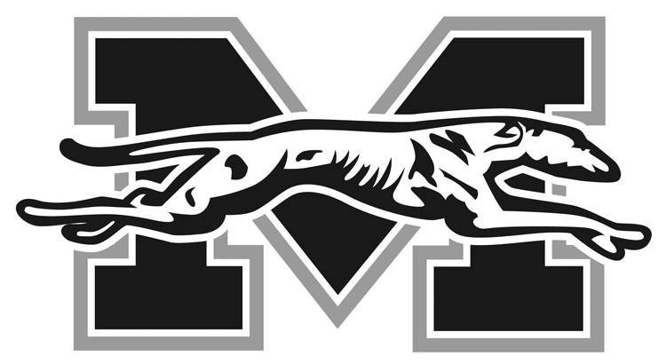
MORAVIAN COLLEGE SPORTS NEWS
Athletic Communications Office

Mark Fleming, Director
1200 Main Street
Bethlehem, PA 18018

Telephone: (610) 861-1472
FAX: (610) 625-7954
Email: flemingm@moravian.edu

Revised, January 26, 2021

2020-21 MORAVIAN COLLEGE

MEN’S BASKETBALL ROSTER

NO NAME YR POS HT WT HOMETOWN/HIGH SCHOOL
0 Joe Paulillo So. G/F 6-3 205 Westwood, N.J. / Paramus Catholic
1 Keith Otto Sr. G 6-1 175 Philadelphia, Pa. / Archbishop Wood
2 Matt O'Connor Sr. G 6-0 165 Philadelphia, Pa. / Father Judge
4 Mike DiPietro Fr. F 6-5 205 Huntingdon Valley, Pa. / LaSalle College
5 Alex Dietz Fr. G 6-1 168 Warrington, Pa. / Central Bucks South
10 C.J. Weber Fr. G 5-11 174 Midlothian, Va. / James River
11 Nate Dougherty So. G 6-1 155 Palmerton, Pa. / Palmerton
12 Ricky Melosky So. F 6-2 178 Whitehall, Pa. / Whitehall
13 Greg Eck So. G 6-0 170 East Stroudsburg, Pa. / East Stroudsburg South
15 Samuel Yadush So. G 5-9 173 New Tripoli, Pa. / Northwestern Lehigh
20 Daniel Cooper Jr. G 6-0 185 Lafayette Hill, Pa. / Plymouth Whitemarsh
21 Justin LaBrusciano Fr. G 5-8 145 Lafayette Hill, Pa. / Friends Select
23 Deandre Tillett Sr. G 5-10 158 Bethlehem, Pa. / Bethlehem Catholic
24 Eric Shuttleworth Fr. G/F 6-2 183 Haddon Township, N.J. / Haddon Township
25 Tyler Mish Fr. G 6-1 168 Holland, Pa. / Holy Ghost Prep
30 James Thompson Fr. G/F 6-3 200 Latham, N.Y. / Albany Academy
Head Coach: Shawn Postiglione (2nd season at Moravian, 6th overall)
Assistant Coaches: Jimmy Murray, Dave Whelan, Mike Frew
Captains: TBD

Pronunciations
#0 Joe Paulillo – Paul-ill-oh
#4 Mike DiPietro – da-pete-tro
#11 Nate Dougherty – Doc-er-ty
#12 Ricky Melosky – Mé-law-ski
#15 Samuel Yadush – ya-dish
#21 Justin LaBrusciano – luh-BREW-she-ah-no
#23 Deandre Tillett – till-it
HC – Po-stig-lee-own

